**Assignment-10.2**

**Name:** G.Arun

**Htno:**2403A51291 **Batch:**12

**Task Description#1 AI-Assisted Code Review (Basic Errors)**• Write Python program as shown below.  
• Use an AI assistant to review and suggest corrections

def calcFact(n):

result=1

x=0

for i in range(1,n):

result=result i

return result

def main():

num = 5

FACT = calcFact (num)

print("the factorial of", num, "is", FACT)

t=10

if FACT>10:

print("BIG Number")

else:

print("small number")

main()

**CODE:**

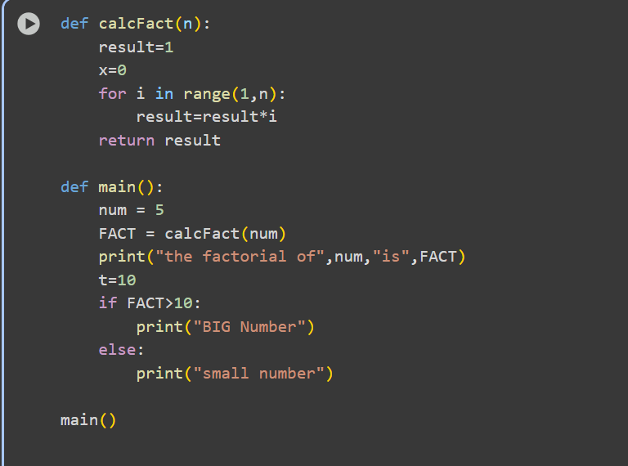

**OUTPUT:**

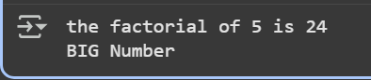

**Task Description#2 Automatic Inline Comments  
•** Write the Python code for Fibonacci as shown below and execute.  
• Ask AI to improve variable names, add comments, and apply PEP8 formatting  
(cleaned up).  
• Students evaluate which suggestions improve readability most. one.

def f1(xx):

b-1

c=2

Zz-[a,b]

while c<-XX:

death

Zz.append(d)

b-d

return zz

def m():

NN-10

ans-f1(NN)

print("fib series till", NN, ":", ans)

m()

**code:**

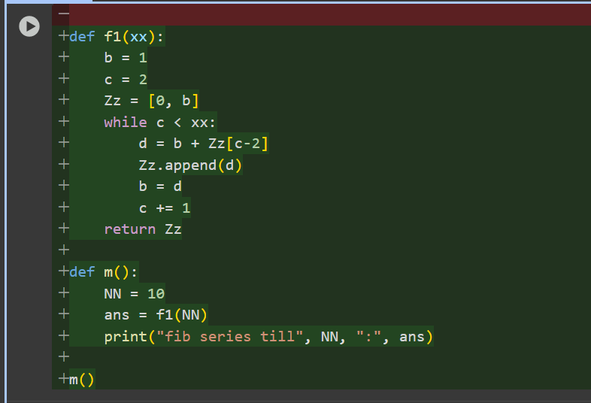

**Output:**



**Task Description#3**

**Prompt:** Create a Python script (add, subtract, multiply, divide) with NumPy-style docstrings, compare with AI docstrings, and explain code smells.

**Code:**

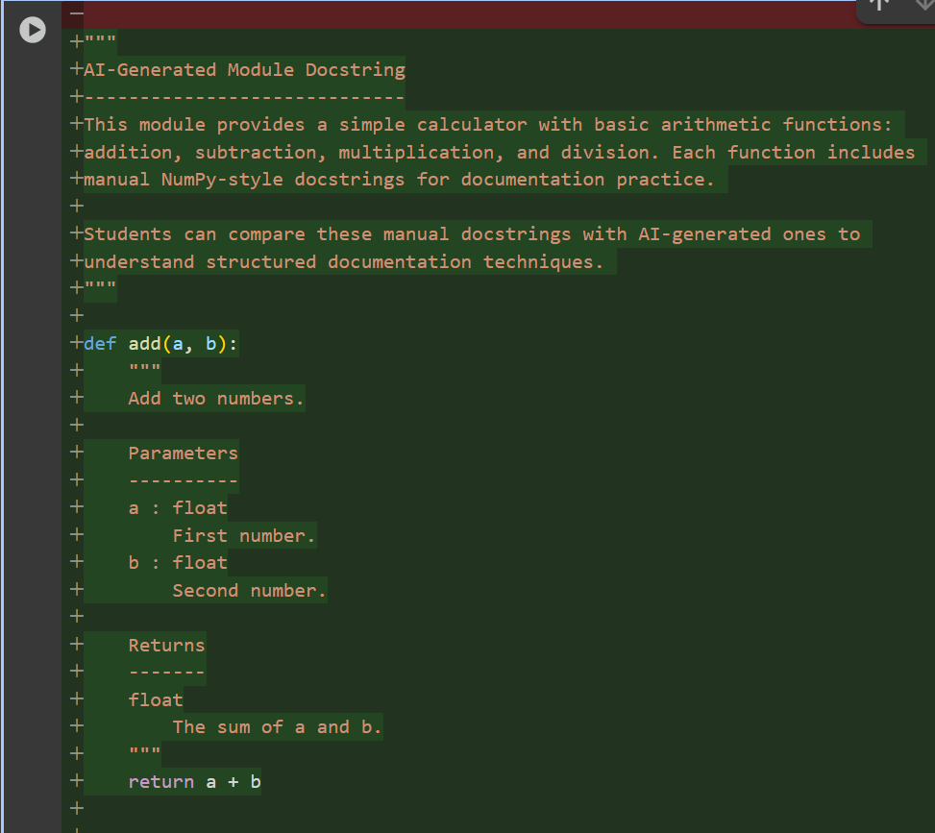

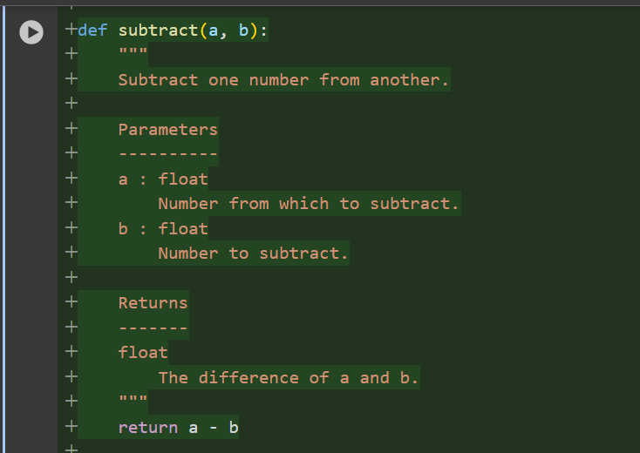

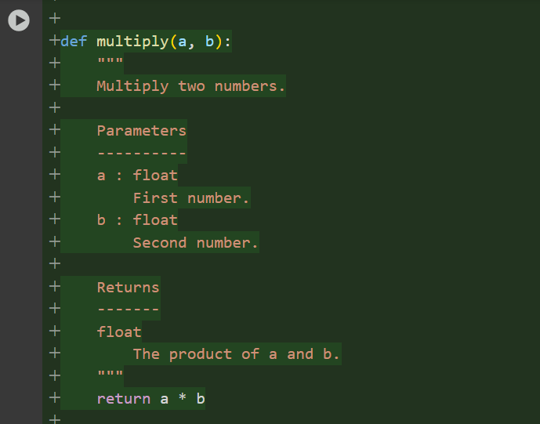

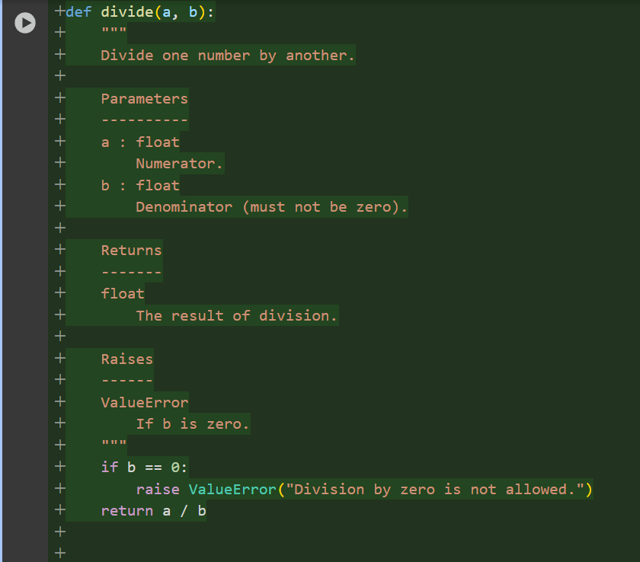

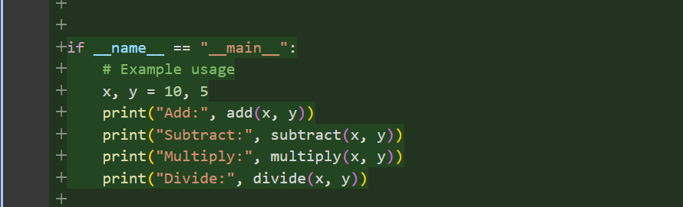

**Output:**

